**IT1060 – Software Process Modeling May-2023**

# Assignment 2 Cover Sheet

|  |  |
| --- | --- |
| **CASE STUDY NAME** | Claim Management System |
| **PROJECT ID** | MLB_04.01_04 |

**Group Details:**

|  |  |  |
| --- | --- | --- |
|  | **Student Registration Number** | **Student Name** |
| **1** | IT22338334 | SHEHARA I G D S |
| **2** | IT22887108 | KUMARAGE N D |
| **3** | IT22316486 | HEWAGAMA A D |
| **4** | IT22336590 | SIRIWARDANA B J A |
| **5** | IT 22326904 | ALWIS D A C |





**BSc (Hons) in**

**Information Technology**



**IT1060 – Software Process Modeling May-2023**

# Assignment 2 Certify Sheet

|  |
| --- |
| I hereby certify,  The attached is my own work and no further changes will be made.  I have contributed in this assignment to the best of my ability.  And I understand,  I may be subject to student discipline processes in the event of an act of academic misconduct by me including an act of plagiarism or cheating. |

|  |  |  |  |
| --- | --- | --- | --- |
|  | **Student Registration** |  |  |
| **Student Name** | **Number** | **Date** | **Signature** |
| SHEHARA I G D S | IT22338334 | 27/05/2023 |  |

**Student Details:**



**BSc (Hons) in**

**Information Technology**



**Part 1**

1)

|  |  |  |  |  |
| --- | --- | --- | --- | --- |
| **Number** | | IT22338334 | | |
| **Name** | | Claim Management System | | |
| **Summary** | | Process and handle insurance claims efficiently and accurately | | |
| **Pre-Condition** | | 1. Properly documented claim submission by the policy holder 2. Valid and active insurance policy 3. Compliance with the specified claim submission timelines 4. Verification of the claimant’s identity and eligibility | | |
| **Post-Condition** | | 1. Claims are accurately recorded and stored in the system 2. Proper financial calculations and settlements are made for approval claims 3. Claims are efficiently processed and resolved within the specified timelines 4. Accurate claim payments are made to eligible claimants | | |
| **Primary Actor(s)** | | Policy holders/Claimants | | |
| **Main Success Scenario** | | **Step** | | **Action** |
|  | | 1 | | Visit to the system |
|  | | 2 | | Enter the correct user credentials |
|  | | 3 | | Open the claim registration and fill the claim registration form |
|  | | 4 | | Select claim type and system initiates the claim processing |
|  | | 5 | | The system proceeds to access the validity of the claim |
|  | | 6 | | If the claim is valid, the system calculates the amount to be paid based on the policy terms and conditions |
|  | | 7 | | The system generates the payment request |
|  | | 8 | | Claim assessment |
|  | | 9 | | Estimation and Approval |
|  | | 10 | | Claim settlement |
|  | | 11 | | Payment Processing |
|  | | 12 | | Claim closure |
|  | | 13 | | System displays successfully when the claim closure |
| **Extensions** | | **Step** | | **Action** |
|  | | 1 | | System notifies user credential are invalid |
|  | | 2 | | System gives another chance to access the login |
|  | | 3 | | System notifies the claim details are invalid |
|  | 4 | | System notify required fields are not filled completely | | |
|  | 5 | | Change the claim type | | |

2)

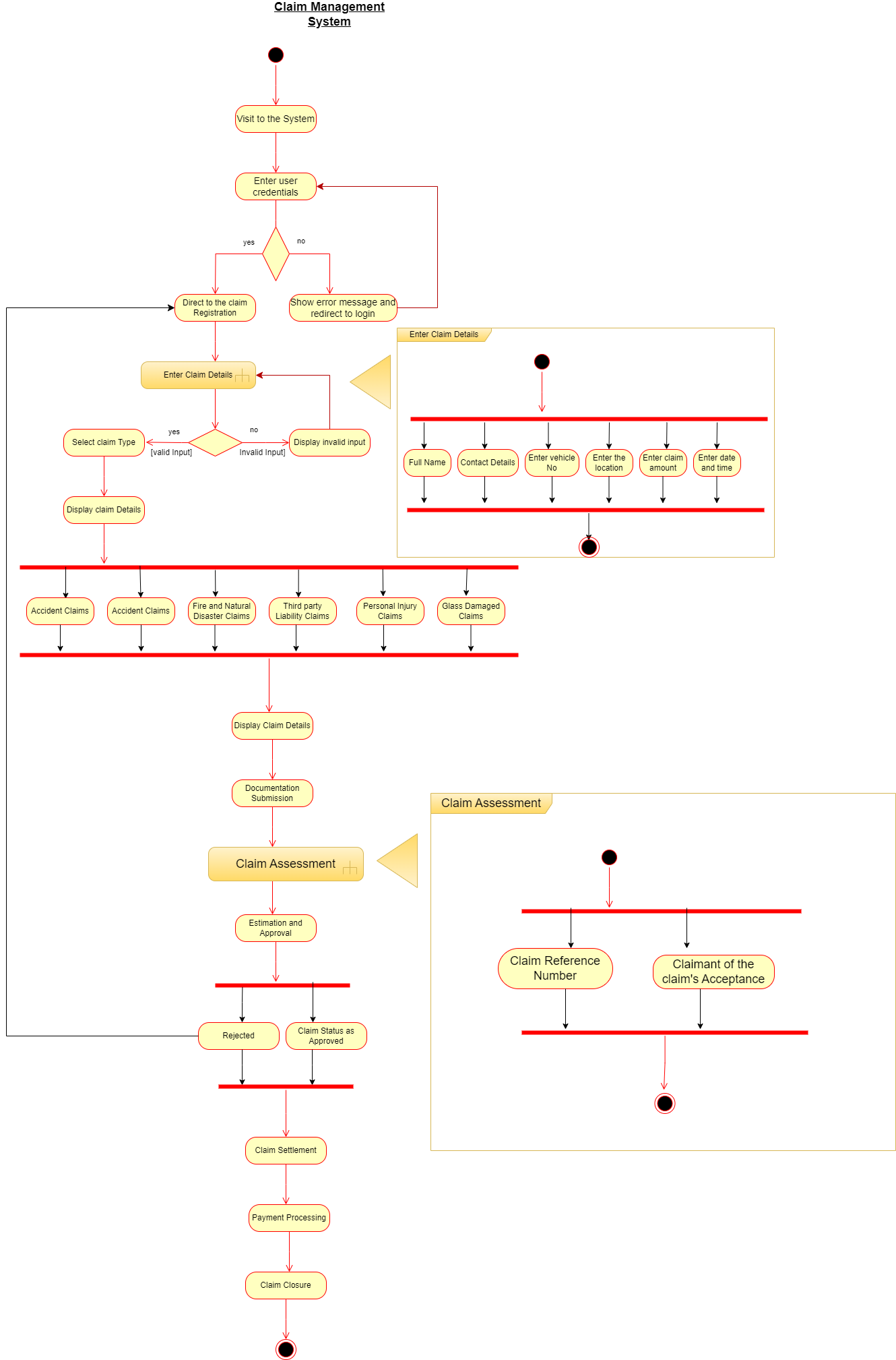

**Part 2**

1) a) Level 1 - Claim Management Subsystem

b) Level 2 - Claim Submission Subsystem

Level 3 - Claim Verification Subsystem

Level 4 - Claim Approval/Rejection Subsystem

Level 5 - Claim Amount Calculation Subsystem

2) 